Ideation Phase
Brainstorm & Idea Prioritization Template

Date | 6 July 2026
Team ID
Project Name | SHOPEZ – E-Commerce Application
Maximum Marks | 4 Marks

Brainstorm & Idea Prioritization Template:
Brainstorming for the ShopEz Premium E-Commerce Marketplace encouraged the team to generate innovative ideas to solve common online retail challenges such as real-time inventory filtering, sizing selection accuracy, dynamic storefront customization, and transaction security. Through collaboration and idea prioritization, the team selected the most practical and valuable features to develop a reliable, secure, and user-friendly ShopEz platform.
Reference: https://www.mural.co/templates/brainstorm-and-idea-prioritization
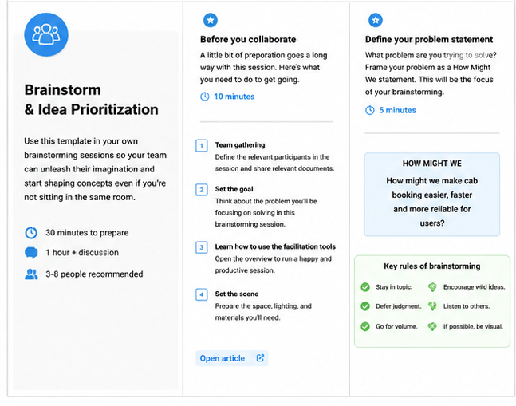
Step-1: Team Gathering, Collaboration and Select the Problem Statement

Step-2: Brainstorm, Idea Listing and Grouping

Step-3: Idea Prioritization

